Experiment -2
NAME:G.CHAKRADHAR
REGNO:192311439
Title:
Online Hotel Room Booking System
Aim:
To design and develop a responsive online hotel room booking website that allows users to search hotels, check room availability, make bookings, and manage their reservations.
Algorithm:
- Start the application.
- Display the hotel booking homepage.
- Allow the user to register or log in.
- Enter destination, booking dates, and number of guests.
- Search and display available hotels and rooms.
- Show room details, price, amenities, and reviews.
- Check room availability for the selected dates.
- Select the required room and fill in booking details.
- Proceed with payment.
- Confirm the booking after successful payment.
- Display/store the booking details.
- Allow the user to view, modify, or cancel bookings according to the specified rules.
- Allow the admin to manage rooms, prices, availability, bookings, and users.
WEBSITE LINK : https://experment-2.vercel.app/

Images:
Intro :


Login and register page :
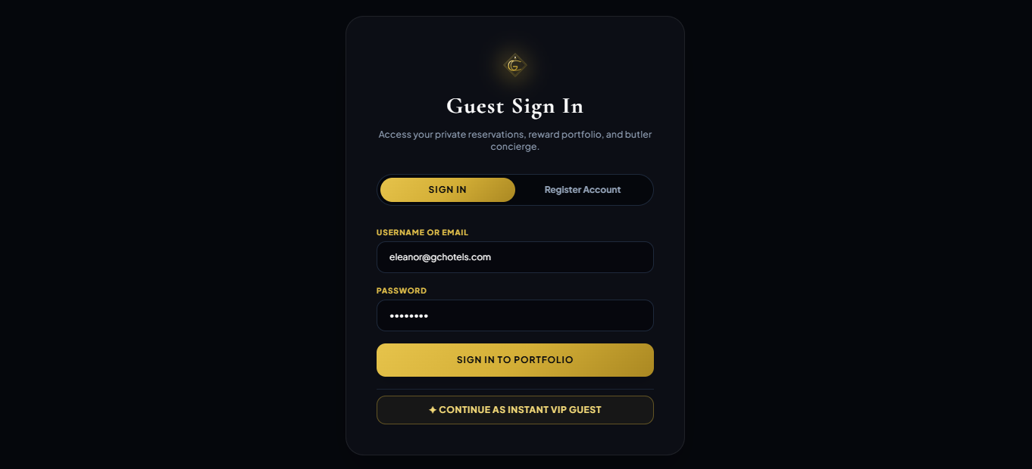
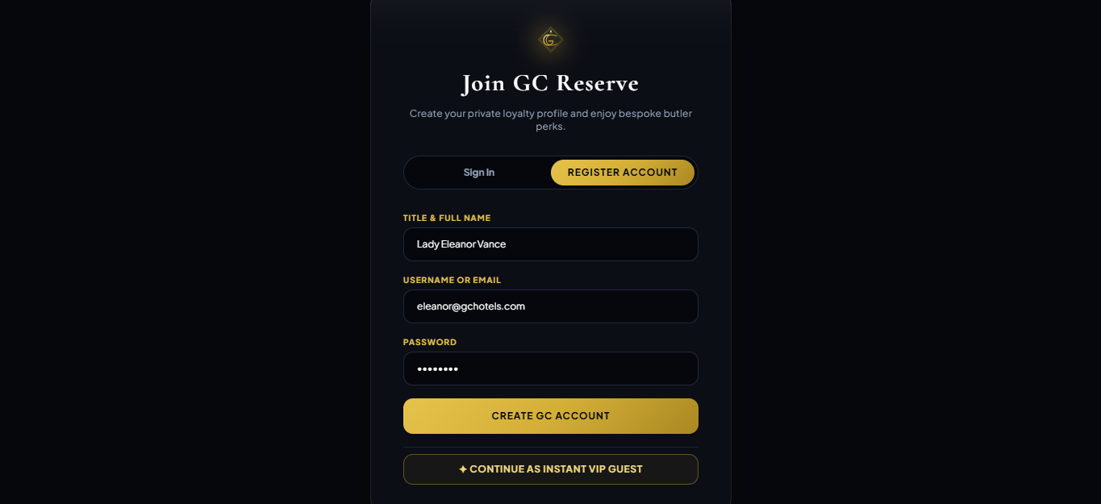

Home page:
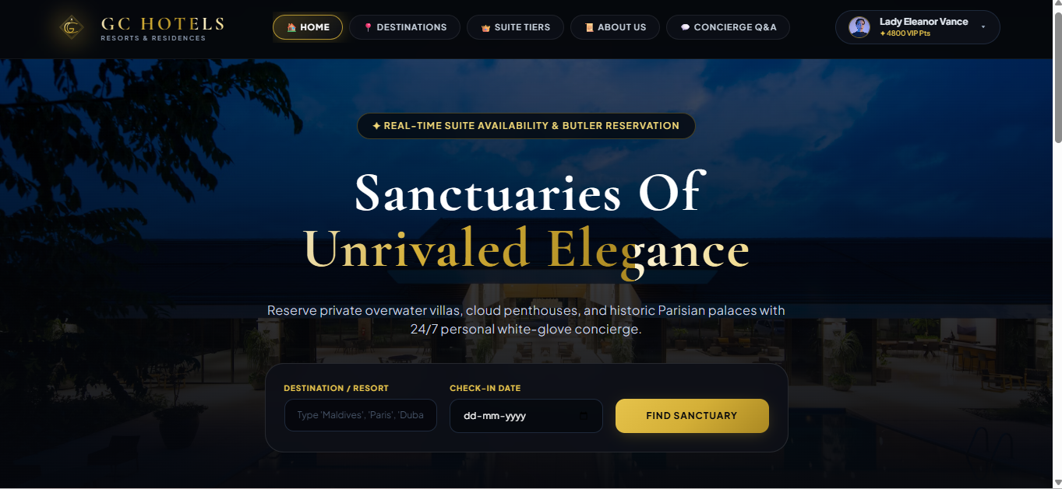

Administrator Control Center
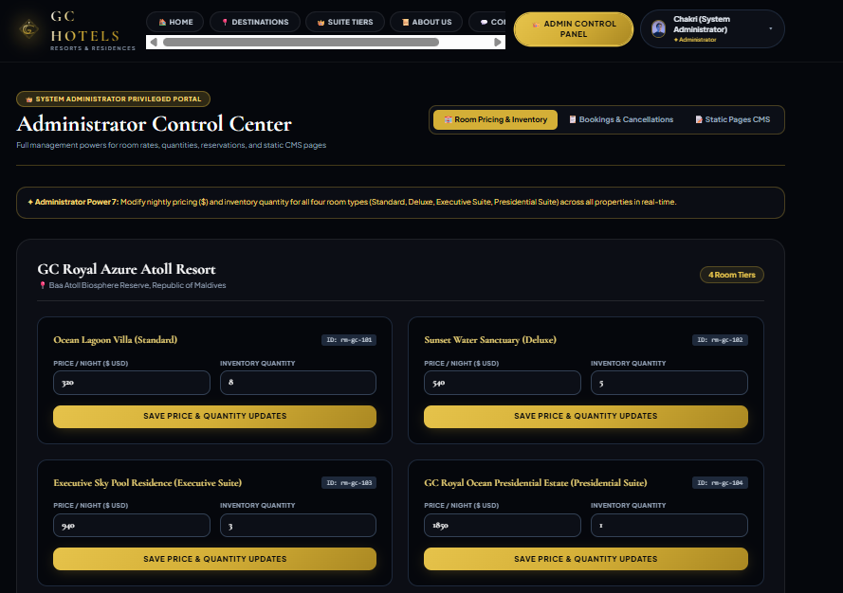
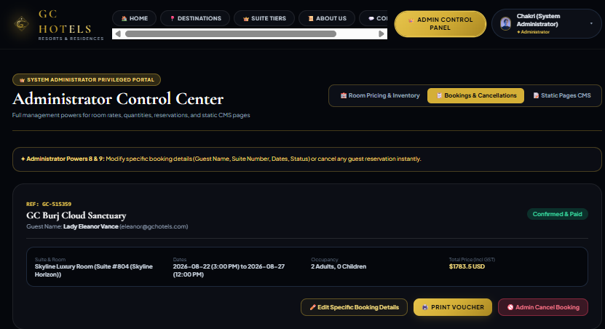

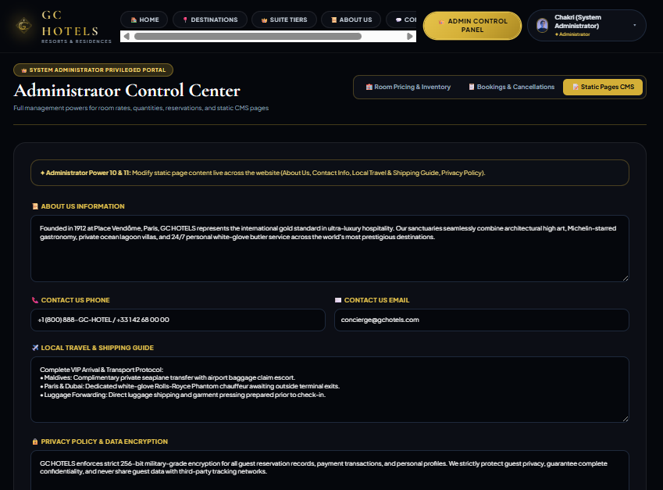

Destination and Hotel info page :
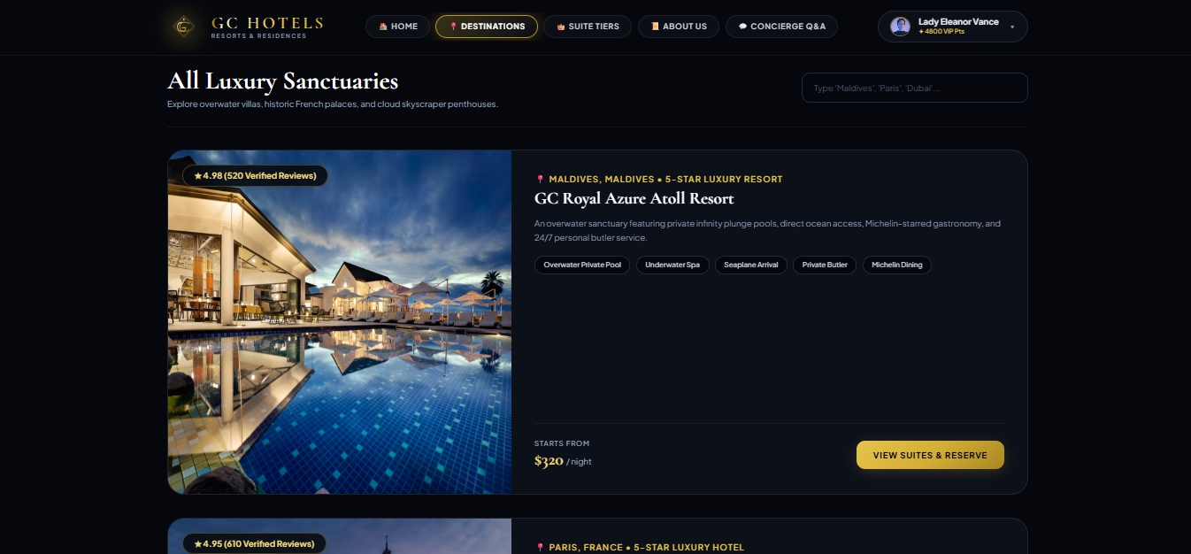

Suite Tiers page :
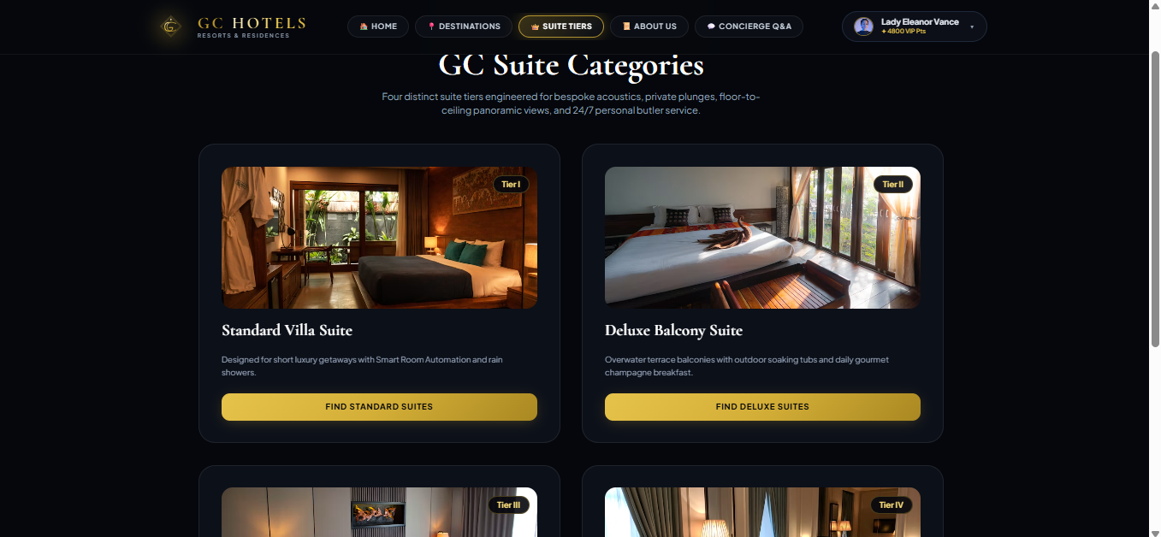

Available Suites and cost and info:
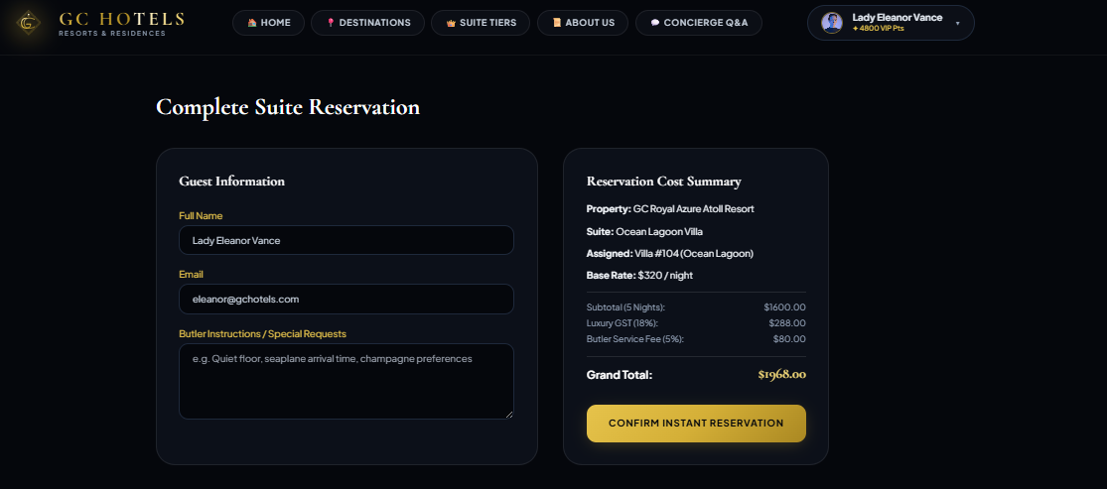

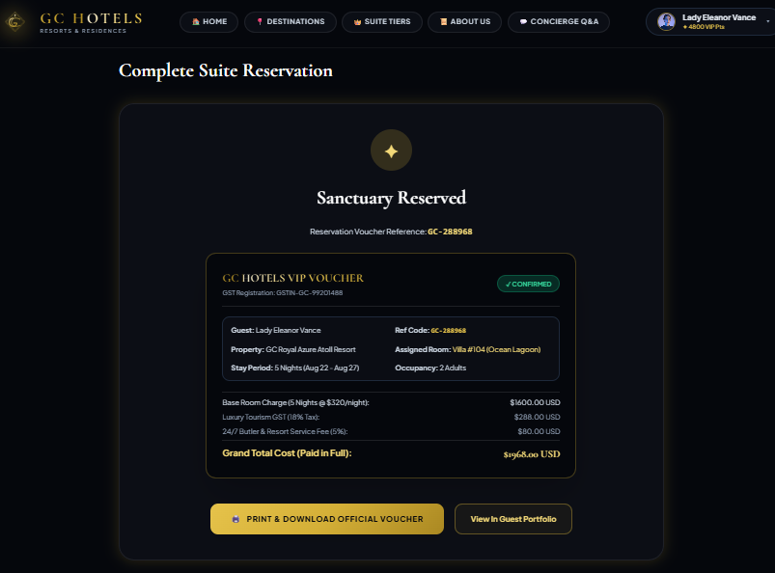

About GC HOTELS

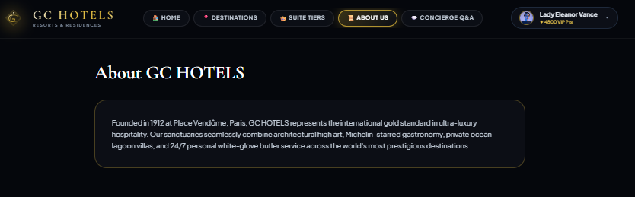

Concierge Q&A

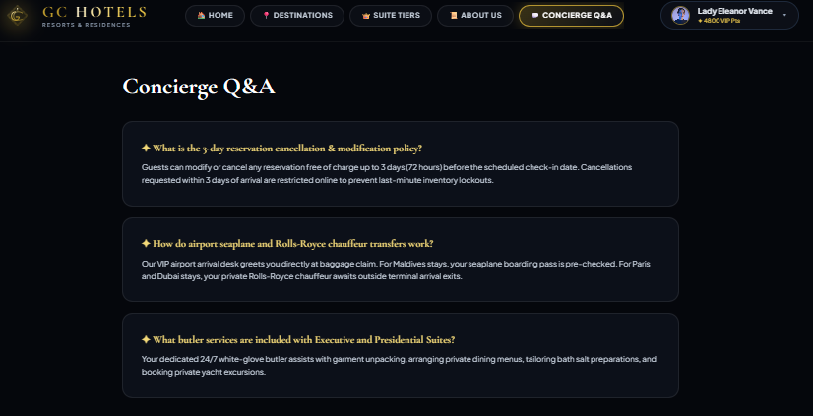

RESULT: The Online Hotel Room Booking System was successfully designed, allowing users to register, search for hotels, check room availability, make bookings, and manage their reservations. Administrators can manage rooms, prices, bookings, and user details.

